Group Creation:
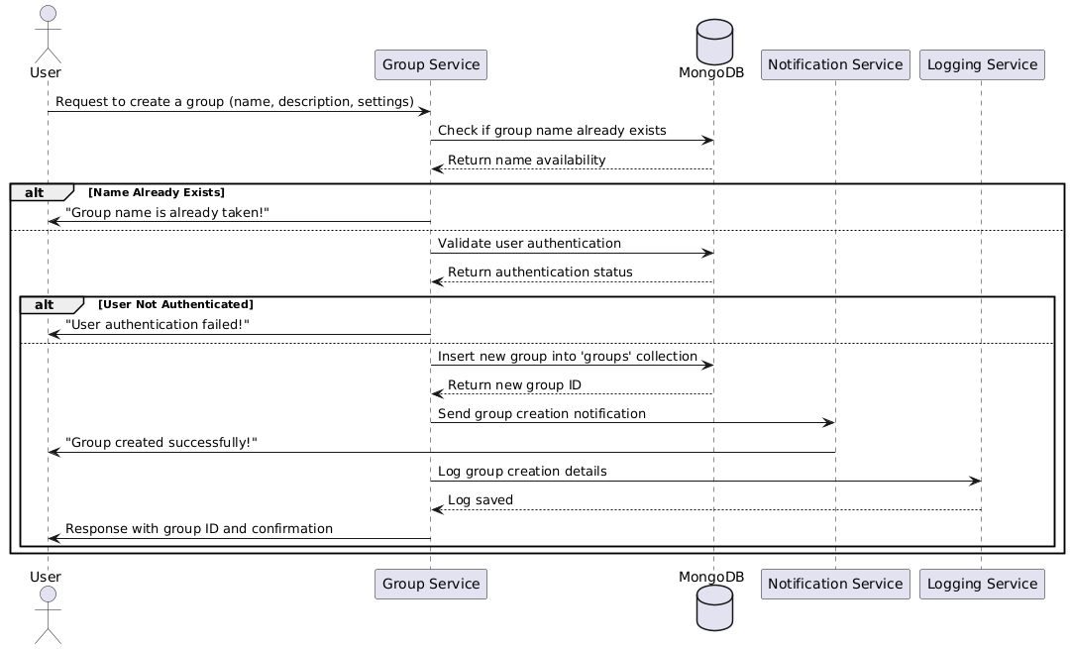

Database:
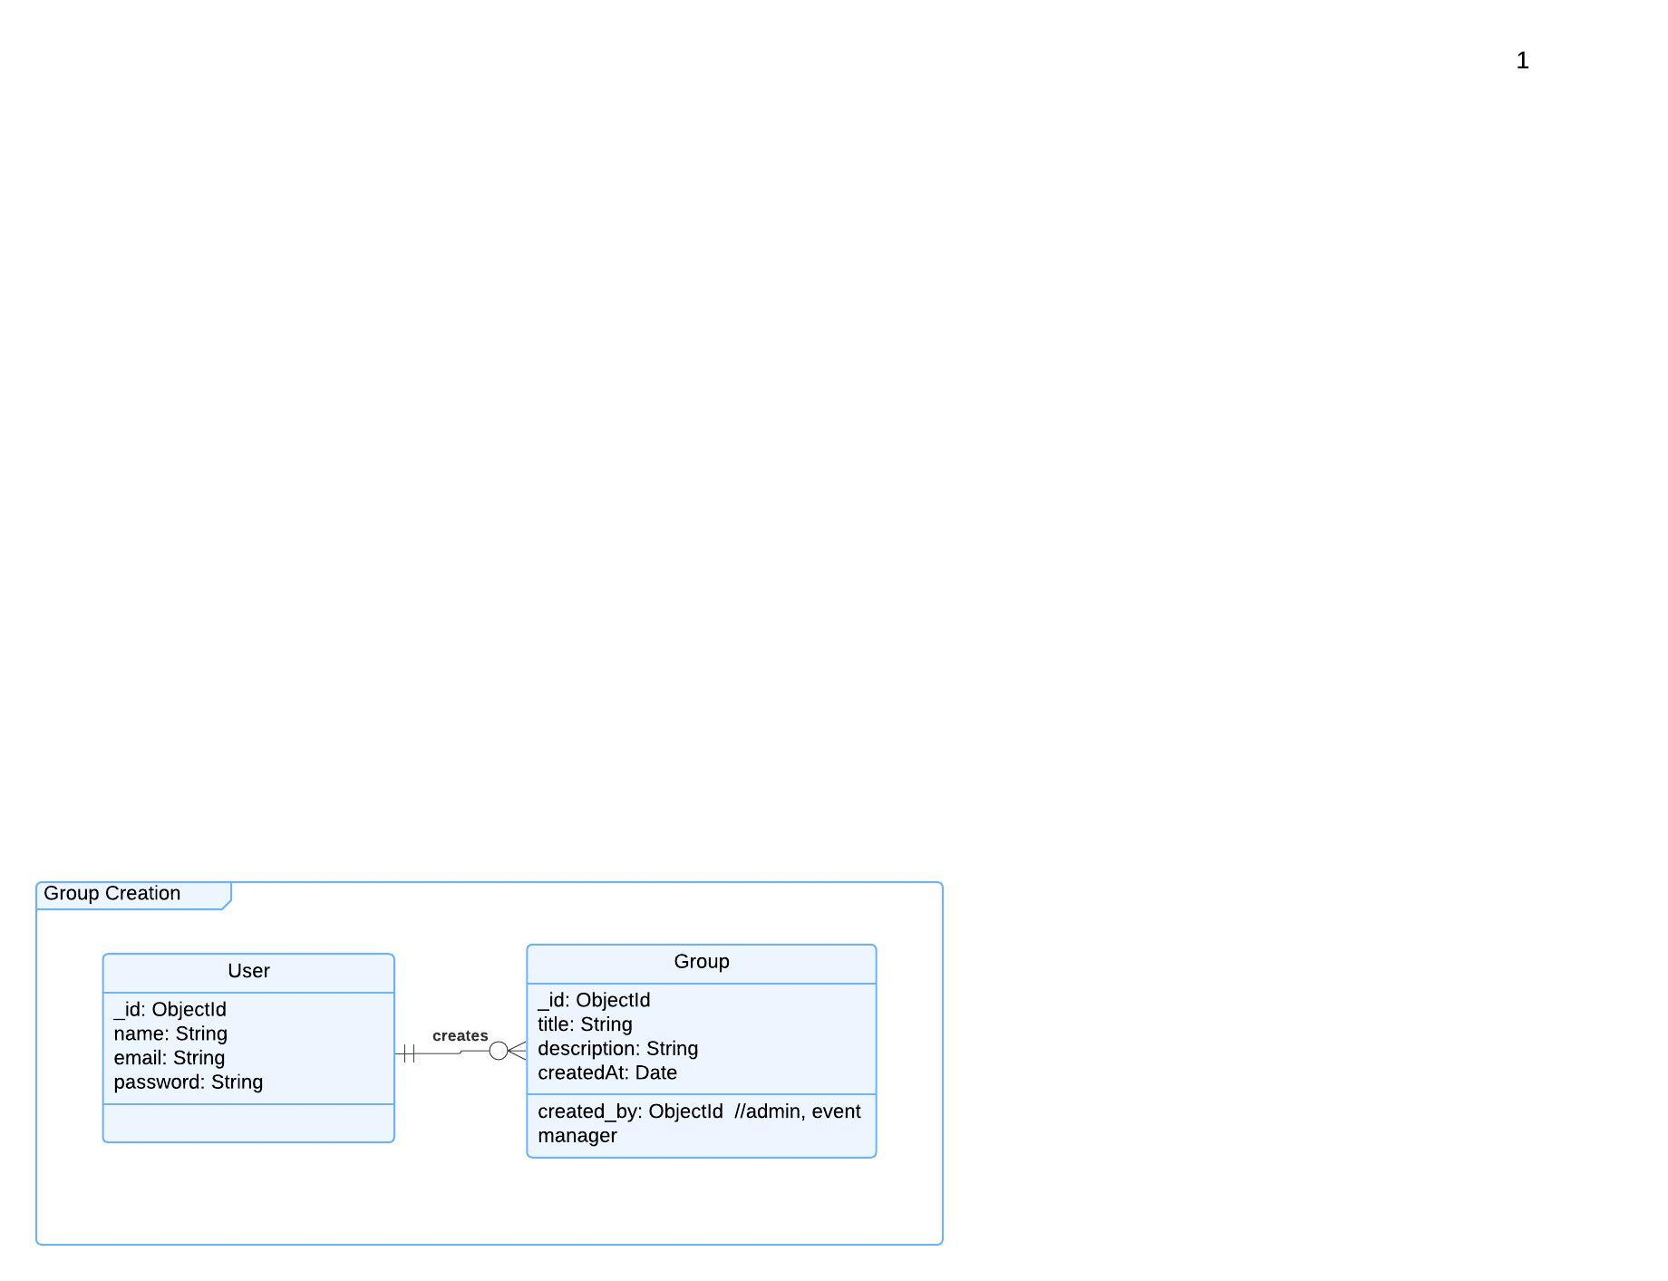

Functional Requirements (FRs)
- FR1: The system shall allow users to create a group by providing a name and description.
- FR2: The system shall validate if the group name is unique before creation.
- FR3: The system shall allow only authenticated users to create groups.
- FR4: The system shall send a confirmation notification after successful group creation.
Non-Functional Requirements (NFRs)
- NFR1: Group creation should be processed within 2 seconds.
- NFR2: The system shall store group data in MongoDB with proper indexing for fast retrieval.
- NFR3: The system shall log all group creation actions for tracking and auditing.

